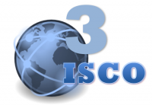
International Scientific Committee of Ozone Therapy

MADRID DECLARATION ON OZONE THERAPY
2nd. EDITION, 2015
Official document of ISCO3
June 12th 2015
“Towards a united approach to the practice of ozone therapy worldwide”

The updating process of the Madrid Declaration took nearly one year since ISCO3 (http://www.isco3.org/) in June 2014 decided to update the document which had been approved in June 2010.

A high and important number of proposals from different parts of the world were received by ISCO3 until January 31, 2015. Based on the proposals received and the inputs by ISCO3 members, several new drafts were written by the principal authors, who received additional proposals from ISCO3 members.

Finally the 21 members of ISCO3 unanimously approved the 2nd. ed. of the Declaration on May 10, 2015 and became an official document of the committee.

You can learn some of methods from Madrid Declaration (June 2015) below.

I. Extracorporeal blood oxygenation-ozonation (EBOO)

This method is used in Italy, Russia. Ukraine, and in some Latin American countries, mainly to treat severe peripheral arterial disease, coronary disease, cholesterol embolism, severe dyslipidemia. Madelung disease, deafness of vascular origin, necrotizing fasciitis, septicemia infection resistant to antibiotics, ischemic stroke, chronic heart failure and viral hepatitis C. The method EBOO is an advanced variant of the Autohemotherapy (AHTmajor). The EBOO amplifies the therapeutic benefits reported of AHTmajor by treating a greater volume of blood (4 L/h) at a lower ozone concentration (<1μg/mL). The procedure EBOO represents a simultaneous oxygenation and ozonation of blood which is transferred from one vein system of the patient to a gas exchange device (GED), and then from GED into another venous system. Upper and lower veins can be used for this procedure. There are two basic procedures of the EBOO.

The first method is based in GED of microporous, ozone-resistant, polypropylene hollow fibers with an external diameter of 200 μm, a thickness of 50 μm, and a membrane surface area of 0.22 m. Concentration of the ozone-oxygen mixture is around 99% and 1%, respectively. During this procedure the patient’s blood is transferred inside the hollow channels, and the ozone-oxygen mixture surrounds the channels from the outside.

The second method is based on the use of rotor and film GED (consisting of a glass bottle revolving horizontally and an immovable cork where are three nipples made of ozone-resisting polypropylene). If the procedures lasts more than an hour, it is necessary to introduce to the patient an extra dose of heparin (1 mL, 5,000 IU) in an hour. The procedure is completed by blood displacement from the lines and GED, using saline solution and removal of intravenous cannulas.

Note: Modern dialyzers used for hemodialysis are made of polysulfone, cuprophan and other non-ozone-resistant materials. The use of such devices for EBOO is provoking a risk of undesirable products of ozone-dialysis in the blood.

SPE “Econika” produce unique equipment “Bozon-N-EBOO” specially for treatments by EBOO-method.
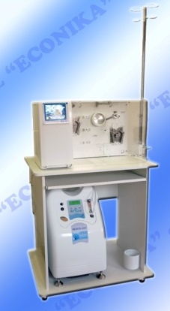
Bozon-N-EBOO>>>

II. Ozonized Saline Solution

The Russian and Ukrainian schools utilize ozonized saline solution (OSS) as another form of systemic application of ozone, and its practice is well extended mainly in these two countries.
Its efficiency is testified by the results of a high number of scientific research studies submitted at the eight Practical Scientific Conferences which took place in Russia from 1992 to 2014.

A team of researchers led by Prof. S. Razumovsky, a major world expert in the chemistry of ozone, found out, through an investigation of the processes of the decomposition of ozone in aqueous media, that the decomposition of ozone in the aqueous solution of NaCl is not accompanied by the formation of products different from the oxygen, and no noticeable amounts of hypochlorites and chlorates were observed in particular. This is significant for the medical applications of ozonized isotonic solution.

At the Scientific Research Center of the Nizhny Novgorod Medicine Academy, Russian scientists, under the leadership of the academician A. Korolev, successfully developed the method of ozonated saline solution in October 1977. In April 1979, for the first time in the world, a cardioplegic ozonized solution in the coronary system of a patient with congenital cardiac injury was administered. In November 1986, the first extracorporeal blood ozonation during placement of a prosthetic mitral valve was conducted.

Ozonated saline solution may be prepared by three methods:

- First method: The three needles: Requires constant bubbling of ozone to ensure the solution is constantly saturated with ozone gas.
- Second method: The two needles: The solution is saturated for 10 min and requires rapid transfusion due to the decrease of the concentration over time.
- Third method is a combination of methods using two and three needles. In this case, the ozonation saline method takes two needles and intravenous infusion followed by periodic bubbling ozone from a special tank. The ozone concentration in saline solution is stable.

SPE “Econika” produce a special tank - Module “BOZON-MOF” for the saline solution preparation and conduct procedures with third method

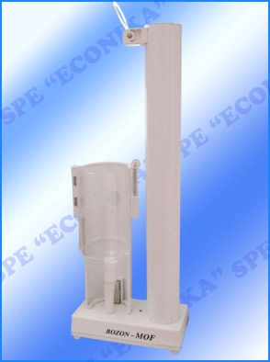

Bozon-MOF>>>

Recommended dose of ozone:

The ozonization is carried out with very low ozone concentrations which are calculated according to the weight of the patient. The formula used is: 20 μg by 1 kg of patient’s weight. For example, if the patient weighs 80 kg, then the multiplication is the following:

80 x 20 = 1 600 μg (1.6 μg/mL or 1.6 mg/L). The ozone concentration in saline is 25% of the concentration of the ozone in the gas. Therefore, if we are continuously bubbling ozone at a concentration equal to 1.6 mg/L, the concentration in saline solution is going to be 1.6 x 0.25 equal to 0.4 μg/mL.

The upper limit of the concentration of ozone in the ozonized saline solution is 2 mg/L; exceeding this limit is dangerous and can cause phlebitis. The exceptional cases are severe sepsis and severe viral infections. In such cases, the concentrations maybe increased up to 8 μg/L.

For the first, second and third methods, three types of dosages are used:
- Low -1 μg/kg.
- Medium - 2 μg/kg,
- High - 5 μg/kg.

Low dosage: For example, using 200 ml of saline solution for a patient weighing 80 kg, the concentration of ozone in the saline solution that the patient will receive corresponds to 0.4 μg/mL
(80 x 20 =1 600 μg (1.6 mg/L) 1.6 x 0.25= 0.4 μg/mL).
Medium dosage: 80 x 40μg = 3.200 μg x 0.25= 0.8 μg/mL;
High dosage: 2 μg/ml, respectively (80 x 5= 400μg; 400 x 0.25= 100 x 80= 8.000 μg)
8.0 μg/mL x 0.25= 2 μg/mL.

Under this method, concentrations generated by the ozone equipment above 3.0 μg/mL are never used.

Note: The volume of saline solution used for one procedure is 200-400 mL. The number of procedures for one course of treatment is 6 to 10. Procedures are conducted daily or even - two days.

Low doses (0.4 μg/mL) are used to stimulate the immune system for diseases of the cardiovascular system, and for obstetrics, to prevent toxicity in the first trimester of pregnancy and fetal hypoxia in the third trimester.

Medium doses (0.8 μg/mL) are used for detoxification in endo-toxemia and chronic inflammatory diseases of different etiologies.

High doses (2 μg/mL) are used in the treatment of infectious diseases, as well as in skin and burn diseases.

